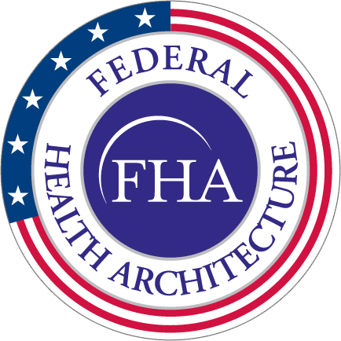**MEETING TITLE Agenda**

**DAY, DATE**

**TIME / Capitol View**

**FHA Health Information Modeling WG**

**Meeting Minutes**

**12/08/2015**

|  |  |  |
| --- | --- | --- |
| 1:10 - 1:20 | **Review Information Modeling work on Radiology and Imaging**   * Completed the information modeling of these two information domains. Began work on next information domain - Clinical Decision Support.  Combined the modeling of the Radiology and Imaging information domains into one domain called “Imaging”. * FHIR has roughly the same structure as the imaging studies in the FHIM domain. * Image interpretation report will bring in the clinical interpretation of the image. * 19 classes unique to imaging, the rest of the classes in the image domain come from other packages. 103 attributes, 14 of which are coded. The next step is for the team to look at those coded attributes and recommend value sets and other changes. * Bob Bishop asked whether videos are included and Galen confirmed that just about any format for videos can be included. | Galen Mulrooney |
| 1:20 - 1:45 | **Review and Discuss Reports Generated from the FHIM Using our Mapping/Categorization Information**   * Changes were incorporated from the suggestions at the last meeting. * Included how much is covered and how much is not covered within a particular specification. * Included how the FHIM maps to and covers a particular standard. * In the process of putting the mapping metadata directly in the FHIM so that edits do not make it automatically out of date. Going forward, just about anything can be mapped to the FHIM (such as a partner’s mapping), not just a standard. * Bob asked for confirmation whether it will not be a straight one to one mapping and Sean confirms that some can be mapped to two or more. * DoD and VA would be able to exchange mappings in this way. * Bob questioned the ease of exchanging mappings if interoperability requires it. Sean agreed that there are challenges but stated that MDMI mapping approach is being leveraged to support these requirements. It will evolve as they identify and support more use cases. * This is a mapping to an information model – we could have something additional that supports mappings to value sets. * Gary Dickenson asked about the functionality to compare certain mappings to identify gaps or overlaps. Galen that stated so far this capability has been manually maintained. S&I Framework initiatives are now mapped to the FHIM. | Galen Mulrooney and Sean Muir |
| 1:45 - 1:55 | **Discussion about Broadening Awareness and Use of FHIM/MDHT/MDA**   * We have modeled all the most critical domains, 80-85% of all information exchanges. The next couple domains will bump this up to 90%. * David asked about the status of the FHIM and FHIR alignment. Is it aligned to the current DSTU2 for all of the resources in FHIR? Galen confirmed that everything he is mapping is aligned to DSTU2, but previously mappings have not been retroactively aligned yet. Galen is in the process of updating them, primarily by pasting the FHIR definition into the FHIM. David requested making the alignment to FHIR as visible as possible to reduce duplication of efforts. Try to line up the profiles in FHIR as to how they reference each other. * Discussion on how to make the benefits of the FHIM apparent to partners. Bob stated that they need to be pushing for broad understanding and adoption of the FHIM at the VA. The nuances and current limitations of the FHIM may be clear to the group but it needs to be made crystal clear to the larger community. | Steve |
| 1:55 – 2:00 | **Wrap-up, and action items** | Caitlin Ryan |